1. 測試內容：

測試L2 Multicast Group Entry with type “ALL”是否正確運行。

1. 測試環境架構：

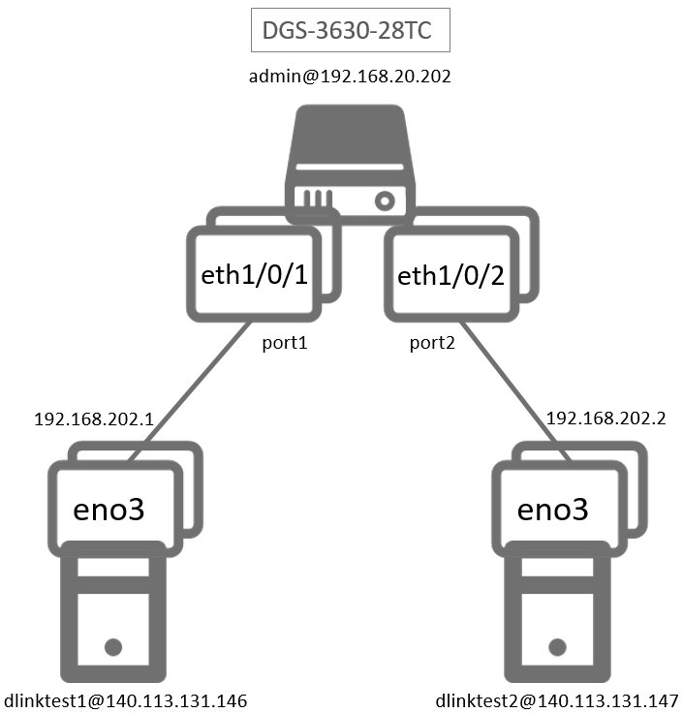

1. 測試環境組態：

* SDN controller: ONOS 1.15.0
* Switch: DGS-3630
* Hosts:
  + ubuntu 16.04.5 LTS
  + dlinktest1(實體機)
    - IP: 192.168.202.1
    - MAC: d0:94:66:5d:5e:08/64
    - Port: 1
  + dlinktest2(實體機)
    - IP: 192.168.202.2
    - MAC: d0:94:66:5c:45:20/64
    - Port: 2
* Apps:

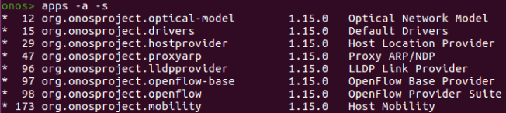

1. 使用之JSON文件：
   * Flow Rule: (附檔：L2_Multicast.json)

|  |
| --- |
| {  "flows": [  {  "priority": 10,  "timeout": 0,  "isPermanent": true,  "deviceId": "of:000078321bdf4000",  "treatment": {  "deferred": [  {  "type": "GROUP",  "groupId": 805371905  }  ]  },  "selector": {  "criteria": [  {  "type": "IN_PORT",  "port": "1"  }  ]  }  },  {  "priority": 10,  "timeout": 0,  "isPermanent": true,  "deviceId": "of:000078321bdf4000",  "treatment": {  "deferred": [  {  "type": "GROUP",  "groupId": 805371906  }  ]  },  "selector": {  "criteria": [  {  "type": "IN_PORT",  "port": "2"  }  ]  }  }    ]  } |

* + Group Rule: (附檔：group1.json)

|  |
| --- |
| {  "type": "INDIRECT",  "appCookie": "0x1234abc1",  "groupId": 65537,  "buckets": [{  "treatment": {  "instructions": [{  "type": "OUTPUT",  "port": 1  }]  }  }]  } |

* + Group Rule: (附檔：group2.json)

|  |
| --- |
| {  "type": "INDIRECT",  "appCookie": "0x1234abc2",  "groupId": 65538,  "buckets": [{  "treatment": {  "instructions": [{  "type": "OUTPUT",  "port": 2  }]  }  }]  } |

* + Group Rule: (附檔：group1AllGroup.json)

|  |
| --- |
| {  "type": "ALL",  "appCookie": "0x3234abc1",  "groupId": 805371905,  "buckets":  [  {  "treatment": {  "instructions": [  {  "type": "GROUP",  "groupId": 65537  }  ]  }  },  {  "treatment": {  "instructions": [  {  "type": "GROUP",  "groupId": 65538  }  ]  }  }  ]  } |

* + Group Rule: (附檔：group2AllGroup.json)

|  |
| --- |
| {  "type": "ALL",  "appCookie": "0x3234abc3",  "groupId": 805371906,  "buckets":  [  {  "treatment": {  "instructions": [  {  "type": "GROUP",  "groupId": 65537  }  ]  }  },  {  "treatment": {  "instructions": [  {  "type": "GROUP",  "groupId": 65538  }  ]  }  }  ]  } |

1. 測試步驟：
2. ONOS GUI

* Flow View：



* Group View：



1. Monitor: Using ping tool

* Let h1 ping h2.

|  |
| --- |
| ping 192.168.202.2 –c 5 |

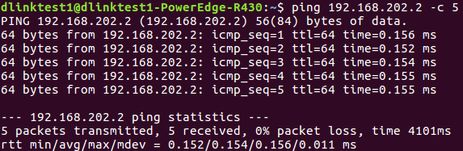

* h1 uses tcpdump to monitor.

|  |
| --- |
| sudo tcpdump –nni eno3 ip |

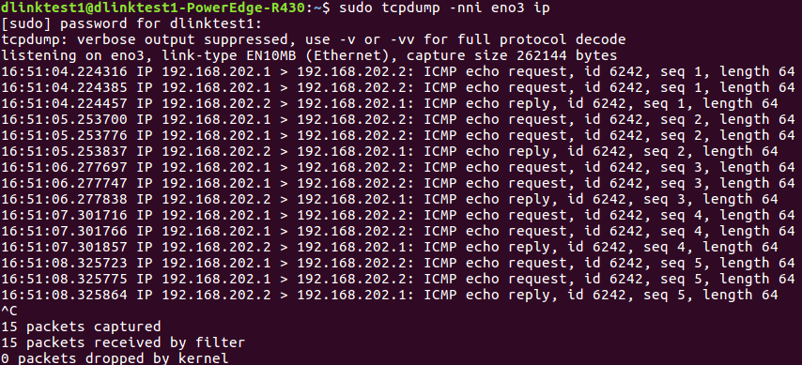

* h2 uses tcpdump to monitor.

|  |
| --- |
| sudo tcpdump –nni eno3 ip |

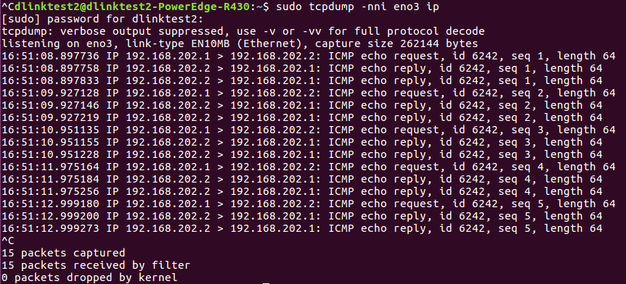

1. Monitor: Switch CLI

* Show group entries.

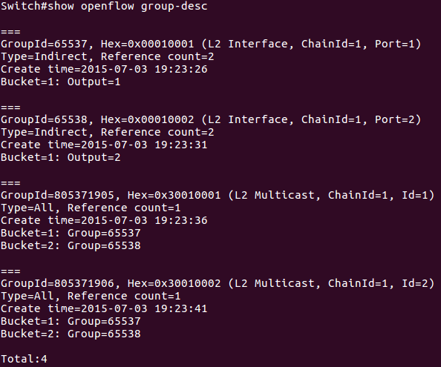

* Show flow entries related to group entries.

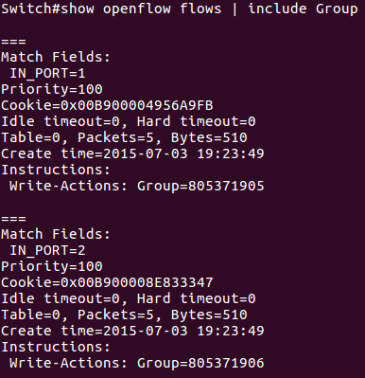

1. Monitor: ONOS CLI

* Show group entries.

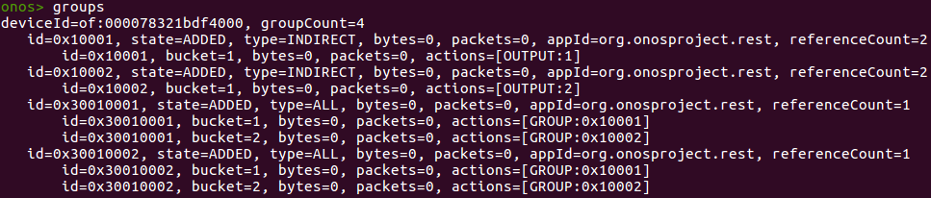

* Show flow entries related to group entries.

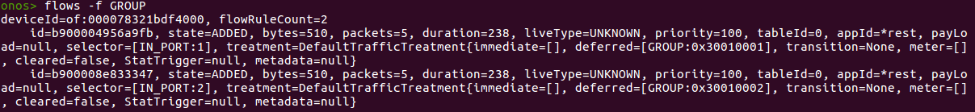

1. 測試結果：

L2 Multicast Group Entry with type “ALL”可以正確運行。